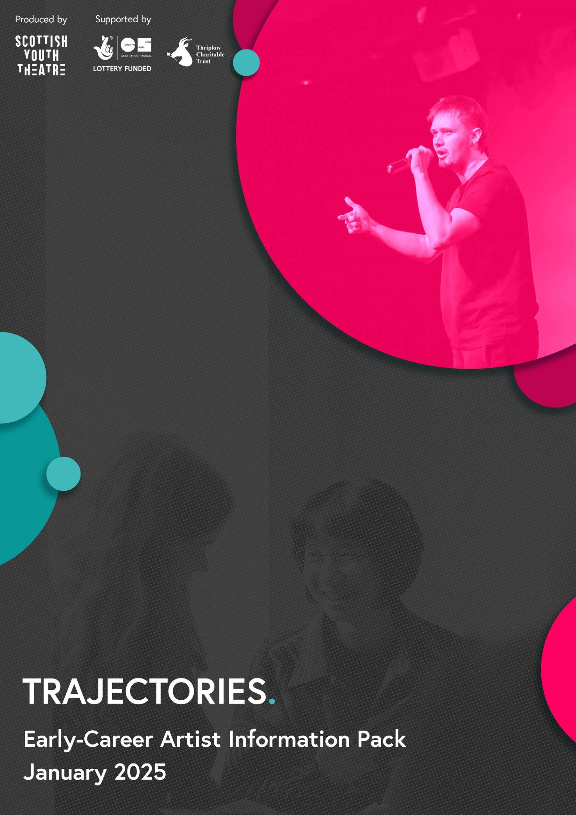
Trajectories
A young artists’ development programme founded on insight, inspiration and crafting new performance

SUMMARY
We are seeking 6 Young Artists, on the cusp of entering professional practice, to undertake Trajectories – a fully supported early-career artist development programme, delivered through a combination of in-person and online workshops, masterclasses and rehearsals. This will culminate in a showcase event of your small-scale theatre production for a public audience. After the final event, you will be invited to work with Scottish Youth Theatre for an extended period to continue your professional development and contribute to future programming and planning with the organisation.
Location: Edinburgh and online

FEE £2,000
Plus access, travel, accommodation and production support

WHO YOU’LL BE WORKING WITH
- 5 other young artists
- A professional Lead Artist who will curate and oversee the programme
- Guest artists and facilitators who will deliver masterclasses and workshops
- Scottish Youth Theatre staff who will support your professional development

PROJECT BRIEF
Trajectories is a supported two-phase bursary programme that invests in 6 early-career theatre artists making new performance work in Scotland. The programme supports you to create a high-quality small-scale theatre production of around 15 – 20 mins, injecting the Scottish theatre sector with new vibrant, dynamic and diverse voices.

PHASE 1
Selected young artists will create a collaborative learning community to explore and develop their arts practice, supported by leading industry professionals to make new work for in-person public audiences in April. Artists will each be provided with:
- A trainee bursary of £2,000
- Access and wellbeing support
- Dedicated time with a professional producer from Scottish Youth Theatre
- Personal professional development planning
- Travel costs
- Accommodation fund (for those living a distance from Edinburgh)
- A production budget of £150 to spend on making your work
It is expected that you will make a new piece of high-quality work, develop your practice and experiment with innovative ideas. You can choose to make a solo show or work in small groups and will have access to a range of performance spaces for the final showcase event on 25 April for industry professionals, peers and wider public audiences.
We don’t expect you to know exactly what you’re going to make yet; that’s what Trajectories is for! We are interested in artists who have already begun a creative journey and have an idea of the type of work they want to explore during the programme. This could be (and is not restricted to):
- New writing
- Movement/Physical Theatre
- Spoken word
- Live art
- Durational performance
- Autobiographical performance
- Multi-art form
- Digital arts
Artists must commit to 2 days per week at the beginning of the project (mostly Mondays and Tuesdays, with some Wednesdays, dedicated to a hybrid model of in-person and digital delivery) plus a rehearsal week and production week. To ensure collaboration and mutual learning sit at the heart of the programme, all artists must attend scheduled days. Some of this time will be for personal research and rehearsal but it is fundamental that artists have no conflicting commitments on these days. Please see the full timeline and key dates below.
For all artists travel costs will be covered to attend the in-person days and accommodation costs will be covered for those who live further away from Edinburgh where daily travel is not an option.


PHASE 2
After the showcase event, all 6 young artists will be invited to extend the collaboration with Scottish Youth Theatre. Inspired by your experience of Trajectories, Phase 2 includes the opportunity to submit a proposal for £500 as seed money for you to take your new work to the next stage or for you to further develop your practice. This phase is designed to be led by you with the SYT team fulfilling a support role to help you achieve your goals.
Phase 2 also includes an invitation to participate in wider company planning sessions, bringing your experience as an early-career artist and as a Trajectories participant, to discussions on future programme and company practice. There will be a separate fee available for attending these sessions.

PROJECT TIMELINE

Phase 1
Applications open: Monday 6 January 2025
Application deadline: 18:00 on Tuesday 28 January 2025
Shortlist for interview/in-person workshop: 31 January 2025
Interviews/in-person workshop: |  | Saturday 8 February 2025 (Edinburgh)*
Applicants notified no later than: |  | Wednesday 12 February 2025
Development Days: |  | 10 & 11 March 2025
 |  | 17 & 18 March 2025
 |  | 25 & 26 March 2025
 |  | 31 March & 1 April 2025
 |  | 7, 8 & 9 April 2025
Rehearsal Week: |  | 14 April – 18 April 2025 (Edinburgh)
Production Week: |  | 21 April – 24 April 2025 (Edinburgh)
Showcase Event: |  | Friday 25 April 2025 (Edinburgh)
Evaluation: |  | w/c 5 May 2025
*travel will be reimbursed for those invited to attend

Phase 2
Submission of proposal by end of May 2025
June – November 2025: 3 company development sessions (dates to be agreed)
Phase 2 completion and evaluation by end of November 2025

HOW TO APPLY
To apply, please complete the application form on our Take Part page.
Alternatively, you may wish to apply via audio or video. The application questions can be found on page 4 of this information pack. Those applying in this way should send their responses in one audio/video file via WeTransfer to annie@scottishyouththeatre.org. Files should last no more than 5 minutes.
If you would prefer to apply in an alternative format or have questions regarding the application, please contact Annie Lowry Thomas on annie@scottishyouththeatre.org.

THE APPLICATION
The first stage of the application process is written questions via the online application form, which are also copied below. From this, Scottish Youth Theatre will invite up to 15 people to attend an in-person group workshop and conversation in Edinburgh on Saturday 8 February from which the final 6 will be selected.
- Please tell us a little bit about yourself and your learning and career journey to date.
- Please tell us about the type of work you make. This could be the artform(s) you work in, the themes or content you explore, do you make solo or group work or both, and why you make the work you do. Feel free to include any links or images of current or previous work that you feel is of relevance.
- Please tell us about a performance, piece of theatre or any other artwork you have seen that has stuck with you. Please describe it and tell us how this work inspired you, what it made you think of and what your audience experience was like.
- If you could make any kind of performance you wanted with any size of budget, with anyone alive or dead, anywhere in the world, what would you do? We encourage you to dream big – this is not a real project or the one you will work on if you are successful for Trajectories.
We actively encourage artists who feel they or their work is underrepresented in the Scottish theatre sector to apply.

Application deadline: 18:00 on Tuesday 28 January 2025
If you would like to discuss if Trajectories is the right project for you before applying, please get in touch with Artistic Producer Annie Lowry Thomas at annie@scottishyouththeatre.org for an informal chat.

MORE INFORMATION
Trajectories previously took place in 2022, at Civic House Glasgow. You can read about the programme here and watch the project film here.

ABOUT SCOTTISH YOUTH THEATRE
Scottish Youth Theatre (SYT) is a national young artists’ development organisation. Our purpose is to collaborate with young theatre artists to create experiences and events that reverberate in their lives, their communities and their country. Scotland is our venue and we seek inspiration in its extraordinary and diverse young people, their untold stories, their aspirations and their creative leadership. No one needs permission to make theatre; SYT seeks to create the conditions and inspire the passion and commitment for young people to tell the stories they want to tell, at the helm of the creative process.
Our Vision
Diverse, bold young artists shaping theatre across Scotland.
What we expect of you
We ask you to commit to the whole process, to be open to experimentation and ready to go beyond what you already know. You’ll need to be supportive of your collaborators and appreciative of what they bring to the space. Essentially, you need to sign up to our company values as part of your participation in our projects:
- Cultivating creative possibility
- Weaving collaboration and connection
- Embedding wellbeing and care
- Grounding integrity in all things

EQUALITIES MONITORING
We are currently piloting a new system for Equalities Monitoring of young artists engaged across our projects. This is a really important part of our practice, to address under-representation in our sector and ensure our recruitment processes are fair and equitable for everyone. On submission of your online application, an anonymous Equalities Monitoring form will open in a new tab on your browser. This is optional but we encourage all applicants to complete it to help us monitor the diversity of individuals who are applying for opportunities with Scottish Youth Theatre. The data you share is anonymous and will not be stored with any identifying information.

